**EE576 HW2**

Fehmi Ayberk Uçkun

2015401009

This homework consists of 3 parts.

**For the first part,**

* A color mapping which includes 25 different colors has been created to catalog the colors and to give the user a list of inputs.
* An RGB image is taken from the user as input.
* Its channels separated and are shown to the user.
* A color choice is taken
* Only the specified color of the image has been shown to the user and other pixels painted to the black.

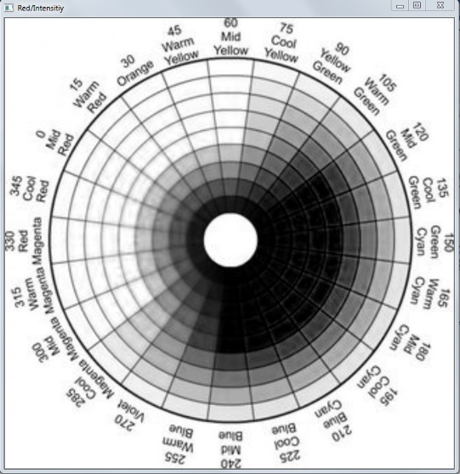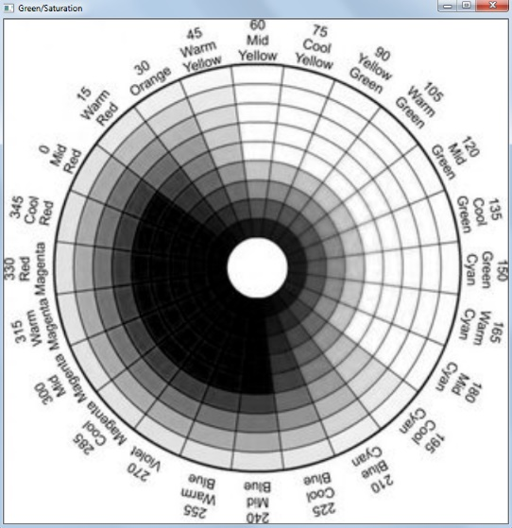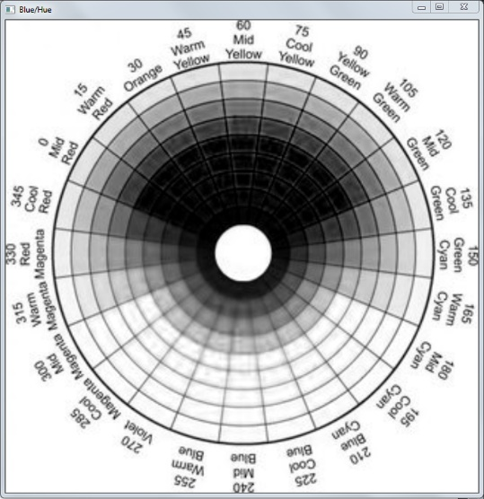

*Blue, Green and Red colors separated.*

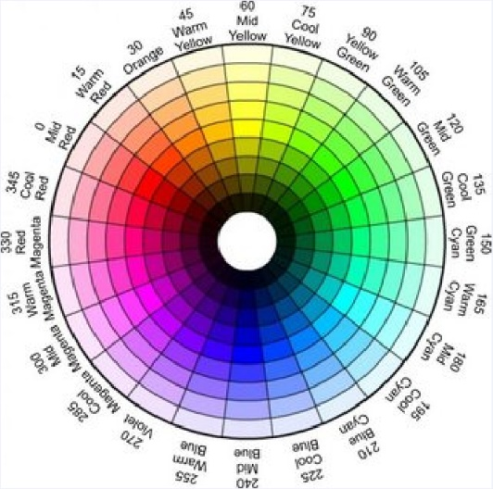

*Original image*

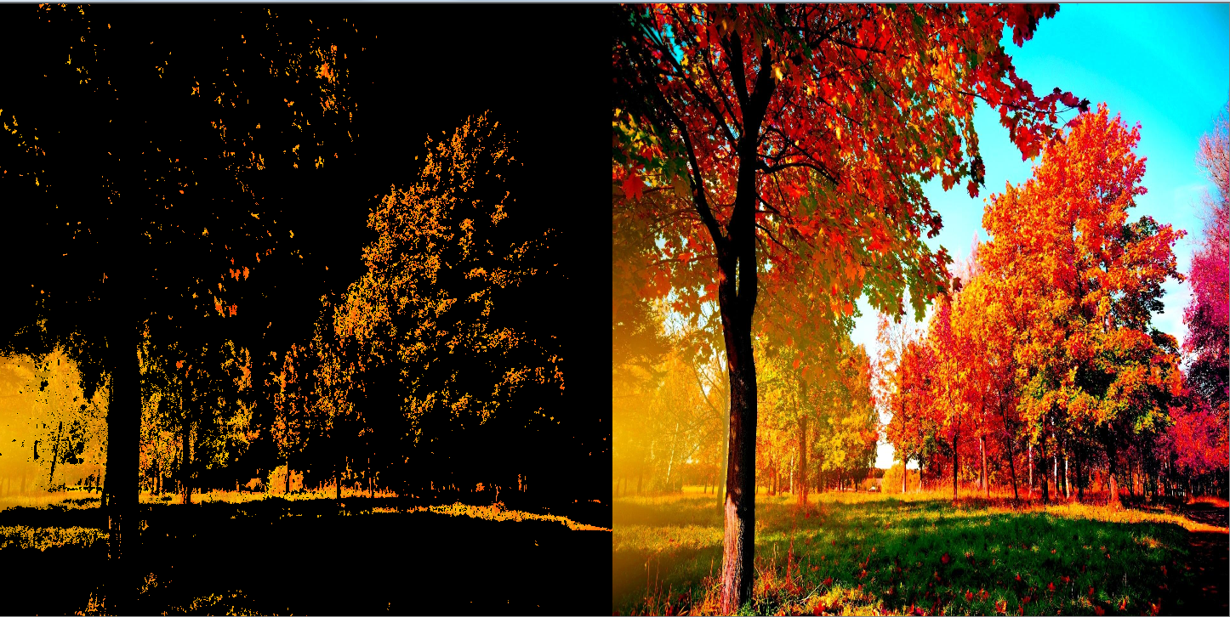

*Orange color specified image*

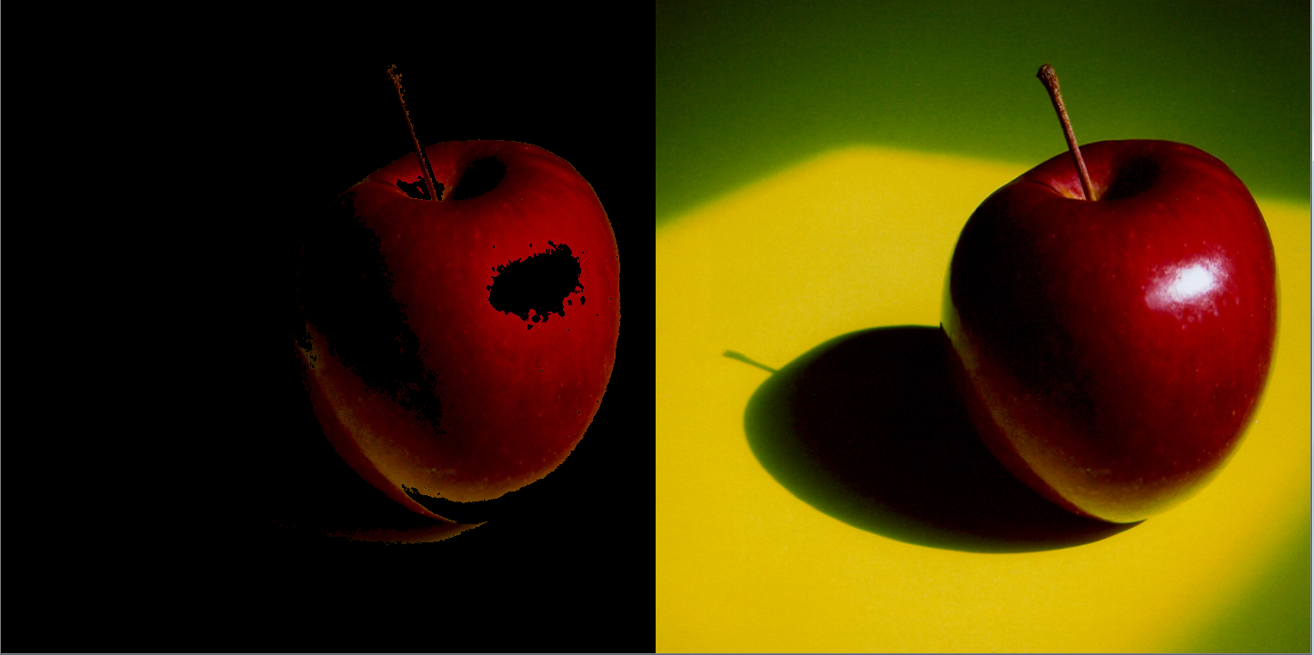

*Dark Red specified image*

Color thresholding algorithm work accurate as can be seen in images. Accuracy can be increased by trial and error but even now user must clearly specify the shade of the color the get a result. (meaning that for the first image if user prompts only green, program gives full black image because only the dark green color is present in the image.

**For the second part,**

* RGB input image converted to HSV color space.
* A new mapping created special to the HSV.
* 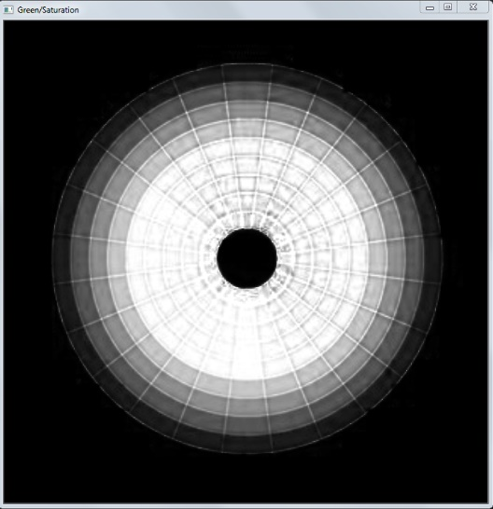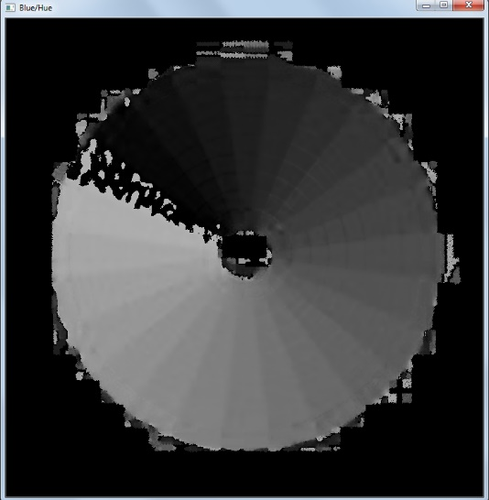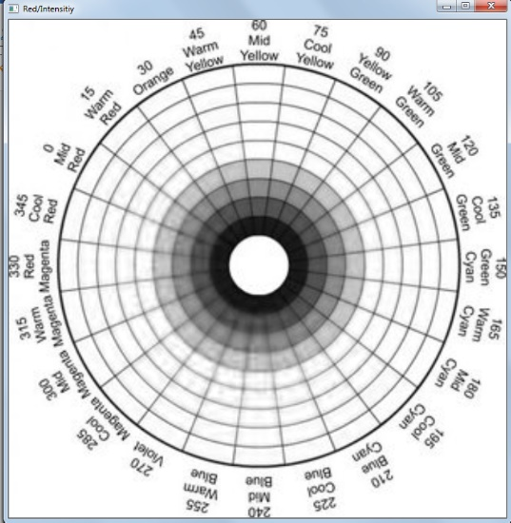Same steps at the first part are applied.

*Hue, Saturation and Intensity/Value separated channels. (Original image same as first part)*

* + First image is the Hue channel. Starting from the 0 degrees, brightness of the grey increases in a radial manner. Thus, it shows yellow darker than violet.
  + Second image is saturation. High saturation means pure color without whiteness in it thus lighter/whiter areas are darker than the middle.
  + Third image is intensity. White means very high intensity and dark means very low thus only the darker sides of the images become dark.

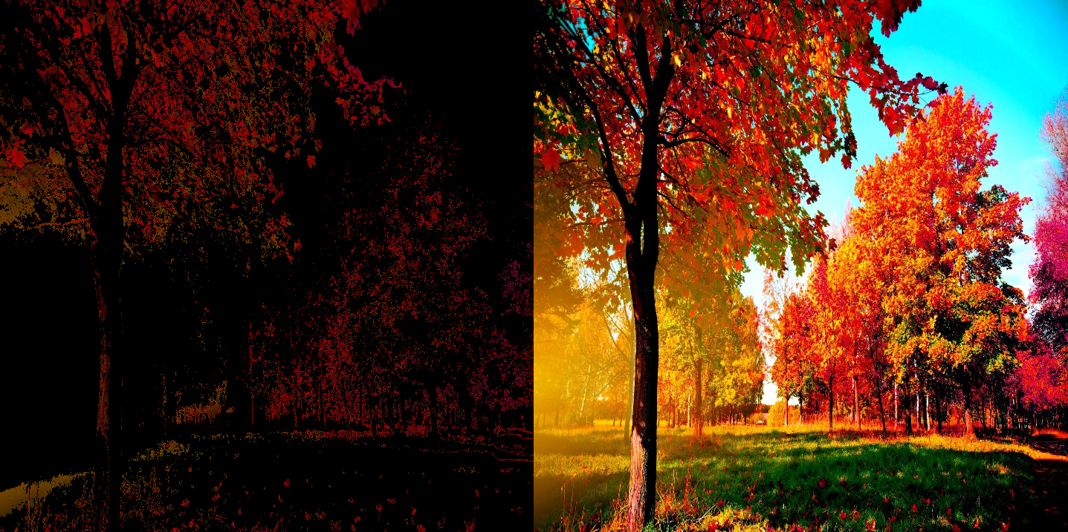

*Dark Red color specified*

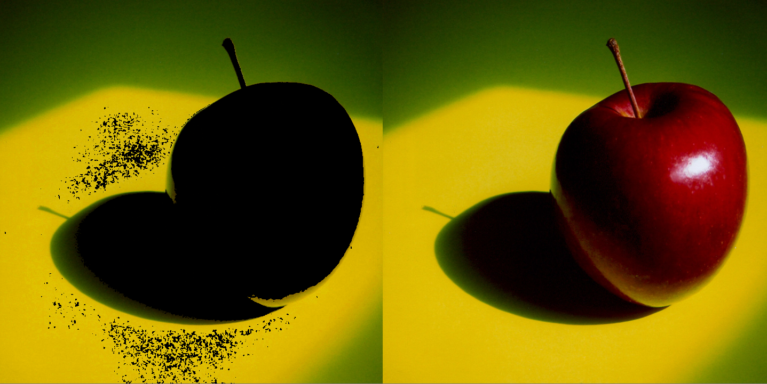

*Dark Yellow color specified*

The thresholding in HSV is different than RGB counterpart. Whiteness, blackness or greyness is not a thing which can be seen in the Hue channel.

* + For whiteness, intensity must be high as much as possible and the saturation should be low enough.
  + For blackness, intensity must be as low as possible.
  + For greyness, saturation must be low and the shade of the gray can be determined via changing saturation.
  + For all other colors, all have a designated angle in a 180 degree half circle and to determine its shade the heuristic method is if saturation is higher then the intensity its darker and vice versa.

**For the third part,**

* Gaussian blur operation has been chosen for this part.
* Built-in OpenCV function is used and applied to the given image.

Below images are the outputs of the program. Left image is after the blur operation and right image is the original one. Blur effect is clearly visible and can be changed using filter size or blur type.

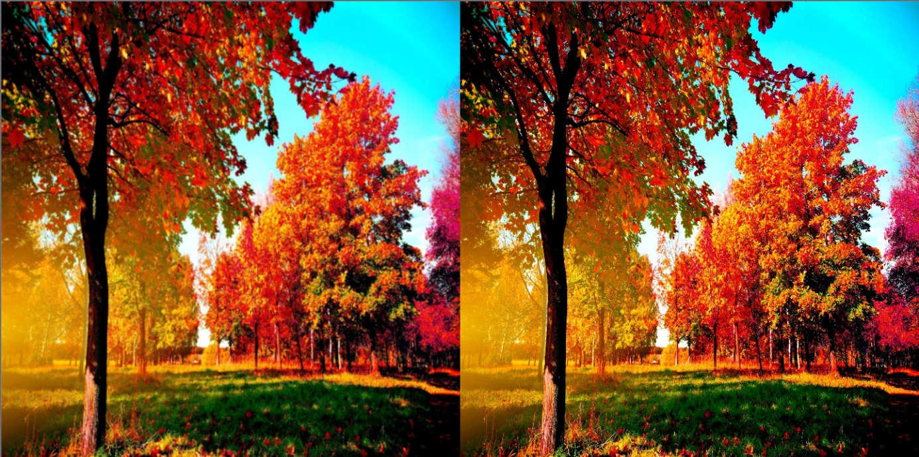

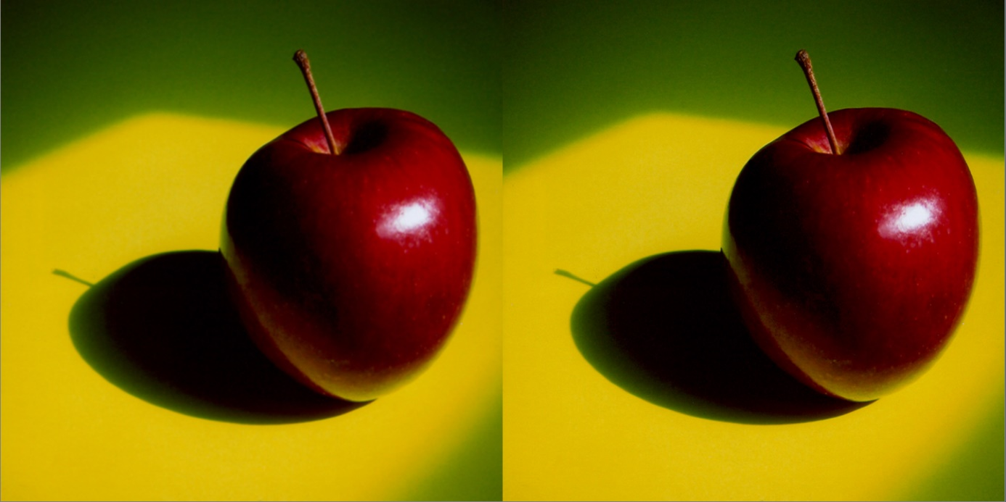

**Instructions:**

1. Specify image name inside main.
2. Run the program.
3. Program asks you to select an operation type ( “rgb”, “hsv” or “gaussian”).
4. If “gaussian” selected, it shows the blurred version of the image side by side with original image.
5. Pressing any key terminates the program.
6. If “rgb” or “hsv” is selected, separated greyscale channels of the image are shown.
7. Press “enter” to continue.
8. Program ask you to specify a color. (name list of colors is given at appendix.
9. Painted image side by side with the original image is shown.
10. Last step continues until user write “stop” or press “esc” while images are shown.

**APPENDIX**

* User can specify all colors named below plus all shades of these colors (i.e. light_red, dark_cyan etc.) except orange and violet.

| Color | Name | RGB | HSV |
| --- | --- | --- | --- |
|  | black | (0,0,0) | (0,0,0) |
|  | white | (255,255,255) | (0,0,255) |
|  | red | (255,0,0) | (0,255,255) |
|  | green | (0,255,0) | (60,255,255) |
|  | blue | (0,0,255) | (120,255,255) |
|  | yellow | (255,255,0) | (30,255,255) |
|  | cyan | (0,255,255) | (90,255,255) |
|  | pink | (255,102,255) | (150,153,255) |
|  | orange | (255,128,0) | (15,255,255) |
|  | grey | (128,128,128) | (0,0,127) |
|  | violet | (127,0,255) | (135,255,255) |

**REFERANCES**

1. <http://opencv-tutorials-hub.blogspot.com/2015/10/splitting-colour-images-into-RGB-channels-split-merge-opencv-code-channels.pushback-src-mv.html>
2. <https://www.opencv-srf.com/2018/03/gaussian-blur.html>
3. <http://isl.ee.boun.edu.tr/courses/ee576/lectures/sunum/color.pdf>
4. <https://www.rapidtables.com/web/color/RGB_Color.html>